STUDENT ENROLLMENT & COURSE MANAGEMENT
SYSTEM (SECMS)

1. INTRODUCTION
1.1 Project Overview
The Student Enrollment & Course Management System (SECMS) is a Salesforce-based application developed to streamline and automate the academic enrollment operations of an educational institution.
The system provides a centralized platform for managing student records, course offerings, enrollments, instructor assignments, approval processes, payments, and reporting.
The application allows administrators and enrollment officers to manage student admissions, course registrations, and enrollment activities in an organized manner. Instructors can also access the required enrollment information related to their assigned courses.
The system uses Salesforce features such as Salesforce Objects, Salesforce Lightning, Flows, Validation Rules, Approval Processes, Reports, and Dashboards to manage and automate different academic processes.
The main objective of SECMS is to replace manual and fragmented enrollment processes with a centralized and structured Salesforce solution.
1.2 Purpose
The primary purpose of the Student Enrollment & Course Management System is to provide a scalable, automated, and secure platform for managing academic enrollment activities.
The system is designed to provide:
- Accurate student data management
- Structured enrollment workflows
- Automated approvals and validations
- Instructor assignment
- Centralized course management
- Transparent reporting and monitoring
- Dashboard-based data visualization
The system helps reduce manual work and provides better access to academic information.

2. IDEATION PHASE
2.1 Problem Statement
Educational institutions often manage student enrollment, course registration, instructor allocation, and related information using multiple manual systems.
The Enrollment Officer needs to manage student enrollments efficiently, but enrollment information may be scattered across different systems and manual processes. This can result in duplicate entries, approval delays, and difficulty in tracking enrollment information.
Administrators also need to track enrollment information and revenue, but when data is not centralized, reporting and decision-making can become difficult.
Therefore, there is a need for a centralized system that can manage student, course, instructor, and enrollment information efficiently.
2.2 Empathy Map Canvas
User Persona: Enrollment Officer
Think & Feel:
- Concerned about double bookings and revenue loss
- Wants accurate enrollment information
- Needs a simple process for managing student enrollments

Hear:
- Complaints from students
- Requests from management
- Follow-ups regarding enrollment approvals
See:
- Multiple spreadsheets
- Emails
- Manual enrollment records
Say & Do:
- Rechecks student and enrollment information
- Follows up manually
- Verifies records before processing
Pain:
- Duplicate entries
- Approval bottlenecks
- Scattered information
- Manual processing
Gain:
- Automation
- Dashboards
- Faster processing
- Centralized information

2.3 Brainstorming & Idea Prioritization
During the brainstorming stage, different solutions were considered for solving the enrollment management problem.
Brainstormed Ideas
- Spreadsheet automation
- Standalone enrollment portal
- ERP integration
- Salesforce-based enrollment system
The ideas were grouped into:
- Manual solutions
- Semi-automated solutions
- Fully automated cloud solutions
After comparing the possible solutions, a Salesforce-based Student Enrollment & Course Management System was selected for implementation.

3. REQUIREMENT ANALYSIS PHASE
3.1 Customer Journey Map
The customer journey of the system covers the following stages:
- Awareness and Registration
- Course Selection
- Enrollment Request
- Fee Payment
- Approval
- Instructor Assignment
- Reporting and Completion
The system supports these stages by storing information centrally and using Salesforce automation for important processes.
3.2 Solution Requirements
3.2.1 Functional Requirements
FR No. | Requirement | Description
FR-1 | Student Management | Manage student records
FR-2 | Course Management | Create and manage courses
FR-3 | Enrollment Processing | Request, approve, and reject enrollments
FR-4 | Instructor Assignment | Assign instructors to enrollments/courses
FR-5 | Reporting | Generate reports and dashboards
3.2.2 Non-Functional Requirements
NFR-1: Usability
The system should provide a simple and user-friendly interface. Users should be able to perform operations efficiently with minimum training.
Examples:
- Quick student registration
- Easy enrollment processing
- Clearly labelled tabs
- Dashboard-based access
NFR-2: Security
The system should protect student and institutional information through authentication, authorization, and access control.
Examples:
- Administrators can manage required records.
- Instructors can view assigned enrollment information.
- Students should not access other students' records.
NFR-3: Reliability
The system should operate consistently during enrollment processing, approvals, and reporting.
Examples:
- Avoid duplicate course registration
- Maintain accurate status updates
- Generate consistent reports
NFR-4: Performance
The system should provide fast response during normal operations.
Examples:
- Quick dashboard refresh
- Fast student record search
- Smooth data processing
NFR-5: Scalability
The system should support future growth in the number of students, courses, departments, and users.
The system should also allow additional modules and features to be added in the future.
NFR-6: Availability
The Salesforce-based system should be accessible to authorized users when required and should minimize downtime during academic operations.

3.3 Data Flow Diagram
The basic data flow of the system is:
User → Student/Enrollment Data → Validation → Salesforce Objects → Approval Process → Instructor Assignment → Reports & Dashboards
The system processes enrollment requests, validates information, routes approvals, assigns instructors, and generates reports.
Data Flow Description
- The user enters student and enrollment information.
- The system validates the entered information.
- Valid information is stored in Salesforce Objects.
- Enrollment information is routed through the required approval process.
- Instructor assignment is handled according to the configured process.
- Processed information is used to generate reports.
- Reports provide information to the dashboard.
3.4 Technology Stack
Layer | Technology
User Interface | Salesforce Lightning
Logic / Automation | Salesforce Flows
Database | Salesforce Objects
Automation | Validation Rules, Approval Process
Reporting | Reports & Dashboards

4. PROJECT DESIGN PHASE
4.1 Problem–Solution Fit
The SECMS project addresses the problem of fragmented academic enrollment processes by using Salesforce as a centralized platform.
The system brings student management, course management, enrollment processing, instructor assignment, approval, reporting, and security into a single environment.
Salesforce-native features are used to reduce manual work and improve the overall management of academic information.
4.2 Proposed Solution
Parameter | Description
Problem | Manual enrollment handling
Solution | Salesforce-based SECMS
Novelty | End-to-end automation
Social Impact | Improved student experience
Revenue Model | Institutional deployment
Scalability | Multi-department support
The proposed solution provides a centralized Salesforce application where academic information can be stored, processed, automated, and reported.
4.3 Solution Architecture
The architecture of SECMS consists of different Salesforce components working together.

Main Components
Users
↓
Salesforce Lightning Interface
↓
Salesforce Objects
- Student
- Course
- Instructor
- Enrollment
↓
Automation Layer
- Validation Rules
- Flows
- Approval Process
↓
Reporting Layer
- Reports
- Dashboards
↓
Security Layer
- Profiles
- Permission Sets
- Sharing Settings
This architecture allows the system to manage academic information and automate important processes within Salesforce.
5. PROJECT PLANNING & SCHEDULING
5.1 Project Planning
The project follows an Agile methodology.
The project is organized using:
- Epics
- User Stories
- Story Points
- Sprint-based execution
- Velocity calculation
The development activities are divided into different sprints and milestones.
5.2 Product Backlog
The major project activities include:
Epic | User Story / Task
Developer Setup | Create Salesforce Developer Account
Data Modeling | Create Student, Course, Instructor and Enrollment objects
Field Configuration | Create required fields
Relationships | Connect related Salesforce objects
UI Configuration | Create tabs and Lightning App
Validation | Configure validation rules
Automation | Create Salesforce Flows
Approval | Configure Approval Process
Reporting | Create Reports
Visualization | Create Dashboard
Security | Configure profiles, permission sets and sharing
5.3 Sprint Planning
The project is divided into sprint-based development activities.
The major development flow is:
Sprint Planning → Object Creation → Field Configuration → Relationships → Automation → Approval → Reporting → Dashboard → Security → Testing
6. PROJECT DEVELOPMENT PHASE
6.1 Milestone 1 – Salesforce Developer Account Creation
The first step is to create a Salesforce Developer Account.
The developer account provides the Salesforce environment required to create and configure the project.
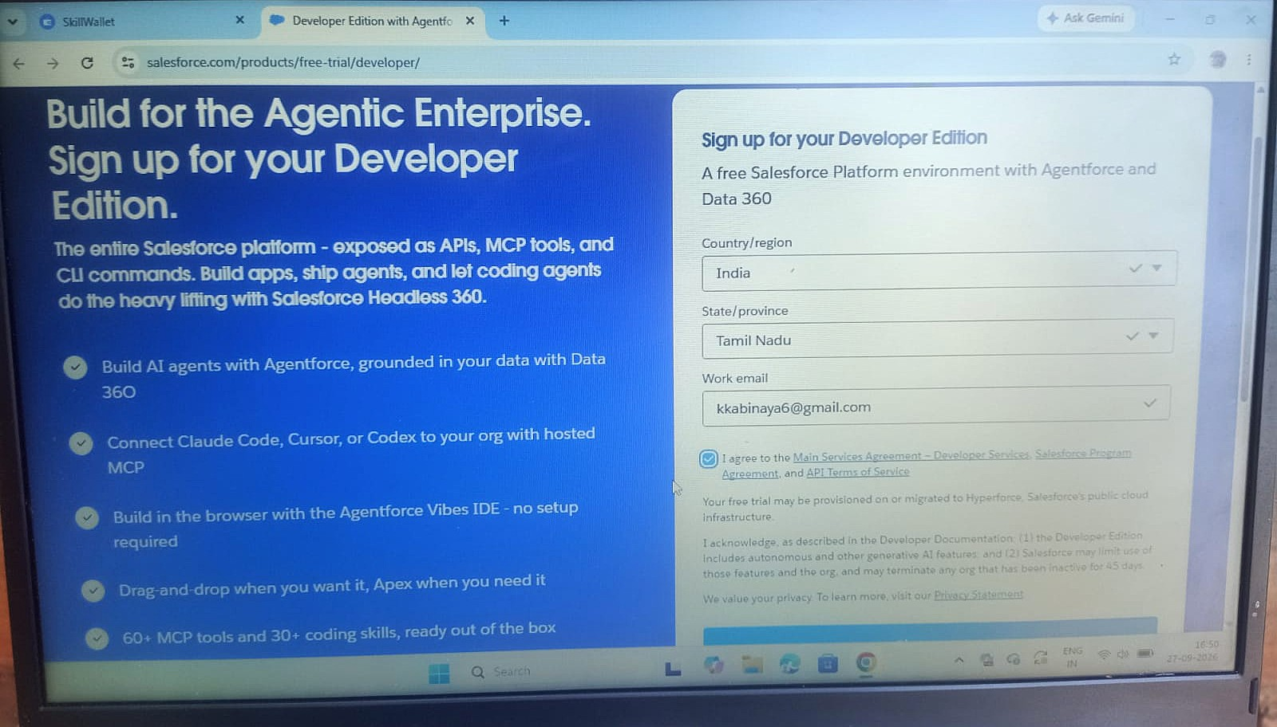
The signup process requires details such as:
- First Name
- Last Name
- Email
- Role
- College Name
- Country
- Postal Code
- Username
After signup, the account is activated through email verification.
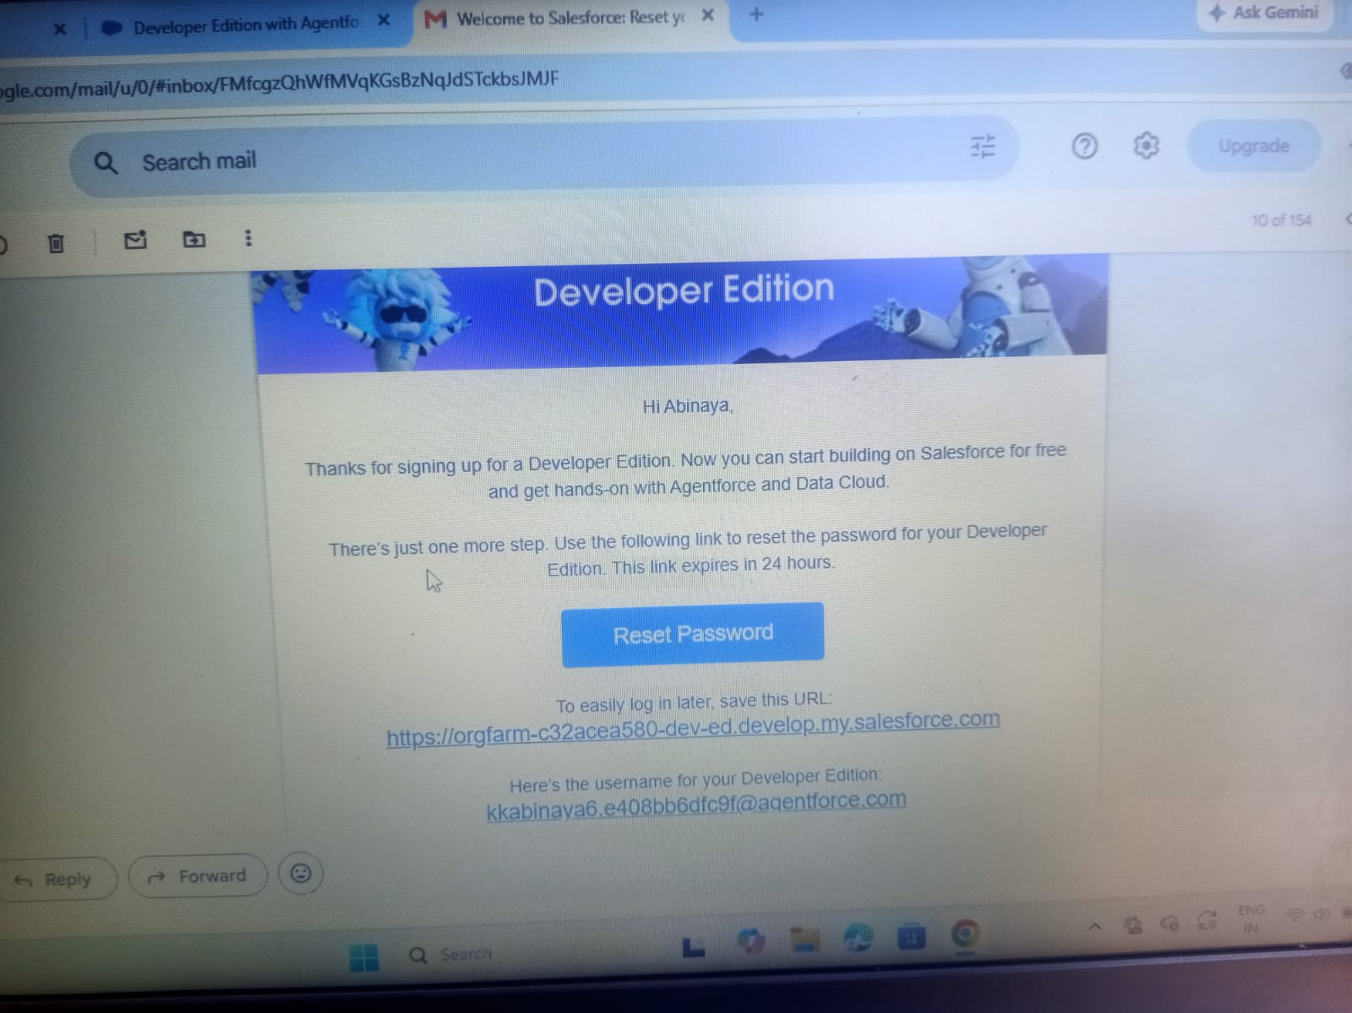
6.2 Milestone 2 – Custom Object Creation
The following custom objects are created:
- Student
- Course
- Instructor
- Enrollment
Student Object
The Student object stores student-related information.
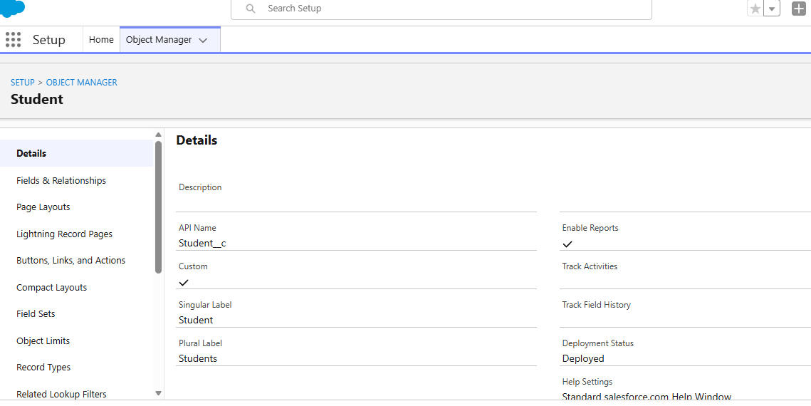
Course Object
The Course object stores information about the courses offered by the institution.
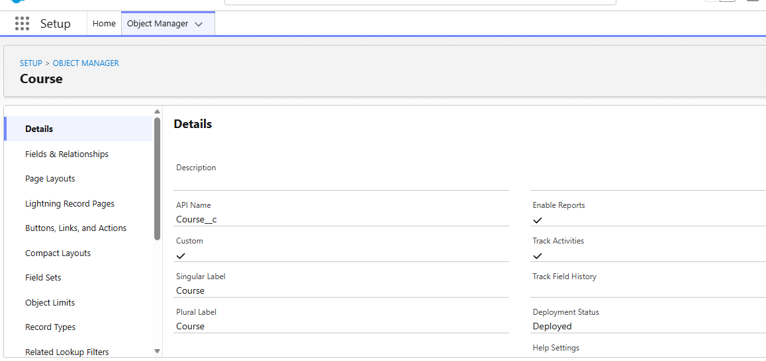
Instructor Object
The Instructor object stores instructor information.
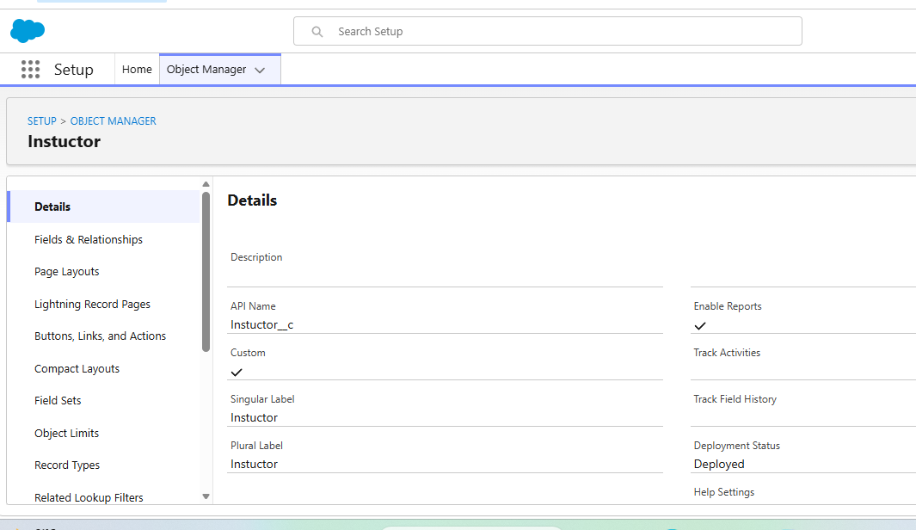

Enrollment Object
The Enrollment object manages student enrollment information.
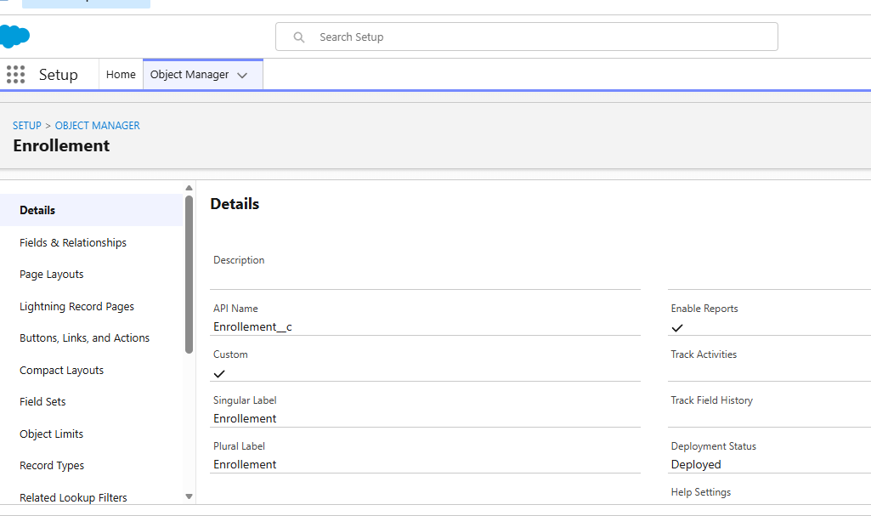
6.3 Milestone 3 – Tabs Creation
Tabs are created for the required custom objects.
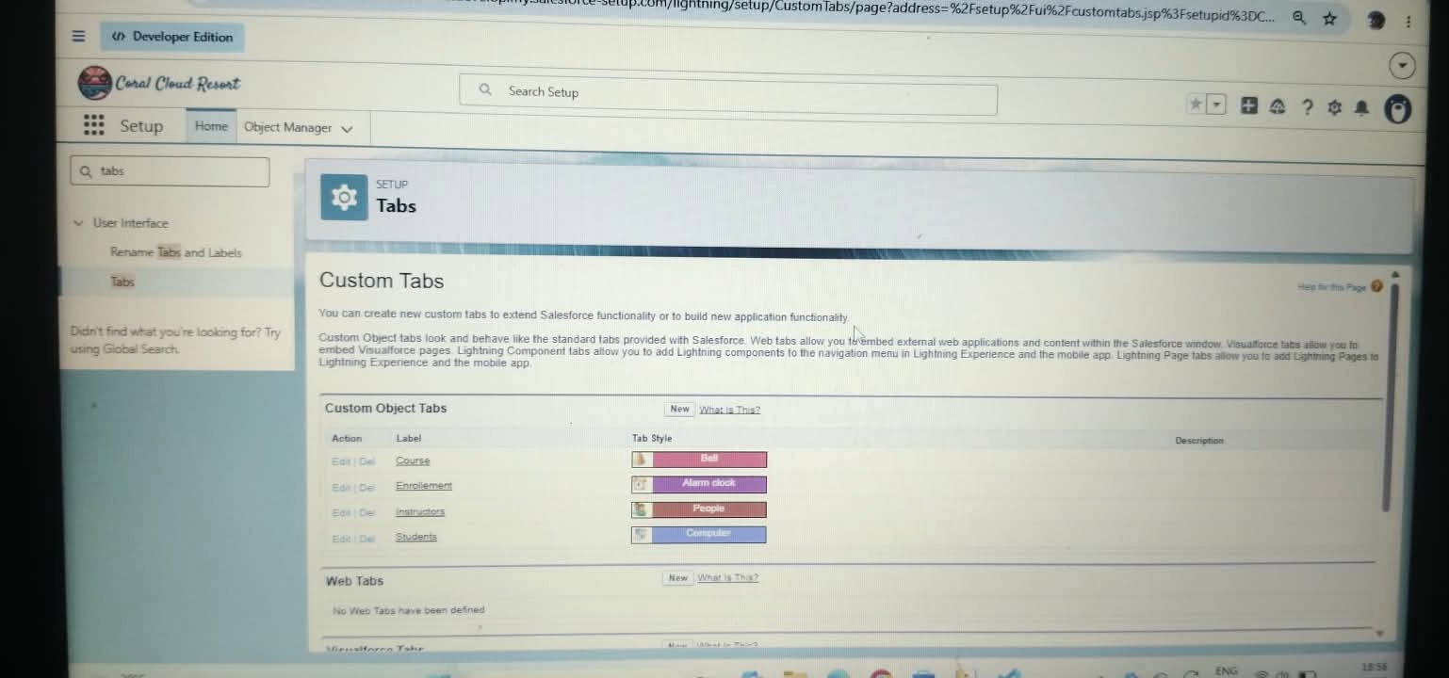
The tabs provide easy navigation to:
- Students
- Courses
- Instructors
- Enrollments

6.4 Milestone 4 – Lightning App Creation
A Salesforce Lightning App is created for the Student Enrollment & Course Management System.
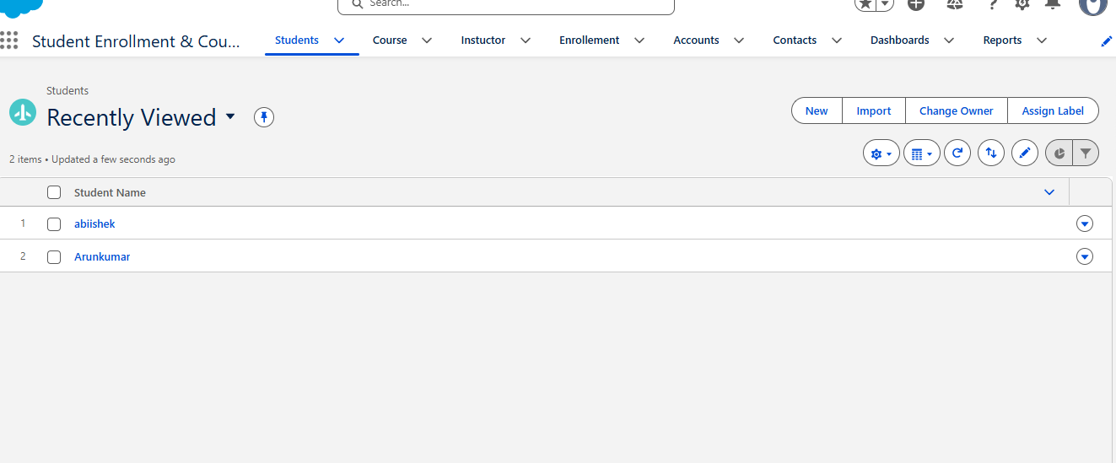
The required custom object tabs are added to the application so that users can access the project components from one location.

6.5 Milestone 5 – Fields Creation
Required fields are created for each custom object.
Student Fields
- Student Name
- Email
- Phone
- Date of Birth
- Gender
- Address
- Enrollment Status
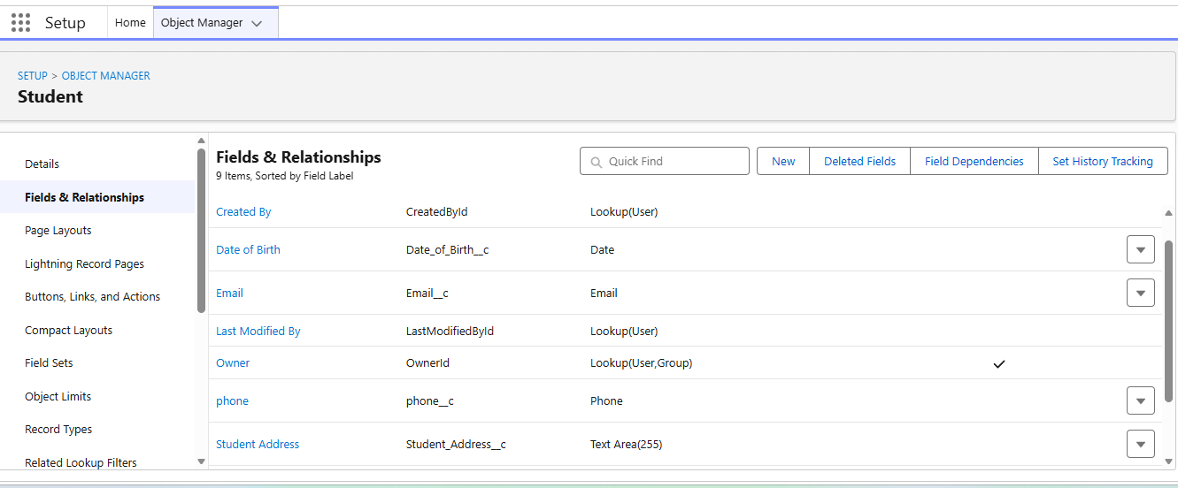
Course Fields
- Course Name
- Course Code
- Credits
- Course Fee
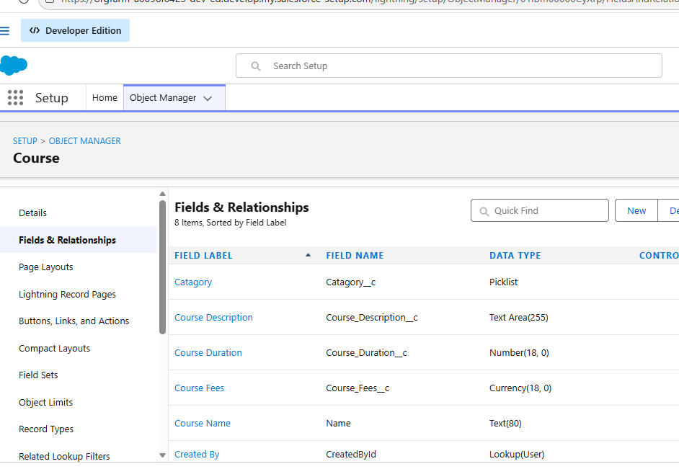

Instructor Fields
- Instructor Name
- Email
- Phone
- Department
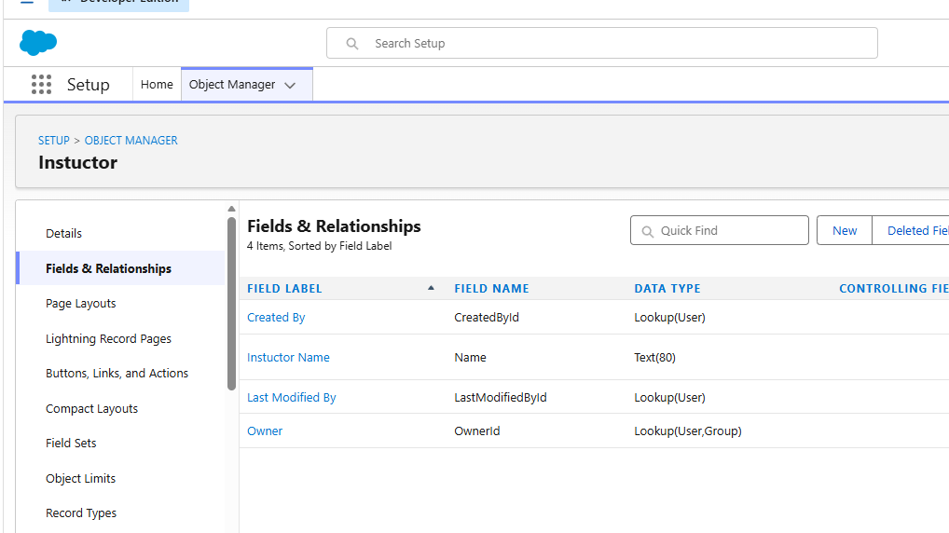

Enrollment Fields
Required enrollment-related fields are created to connect students, courses, instructors, and enrollment information.
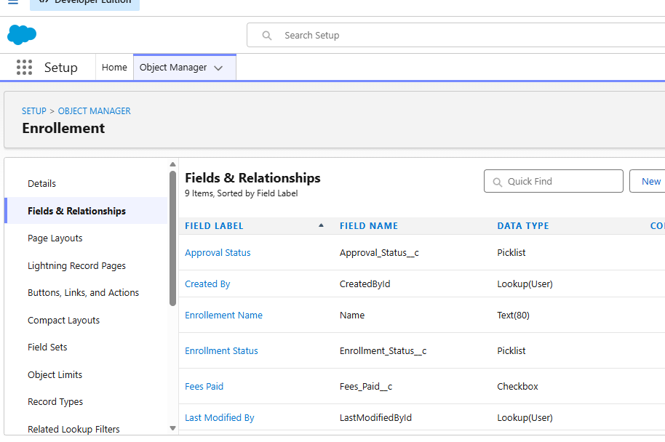

6.6 Milestone 6 – Create Relationships
Relationships are created between the Enrollment object and the other related objects.
The Enrollment object is connected with:
- Student
- Course
- Instructor
These relationships allow related information to be accessed from enrollment records.
6.7 Milestone 7 – Page Layout Customization
Page layouts are customized to organize fields and related lists.
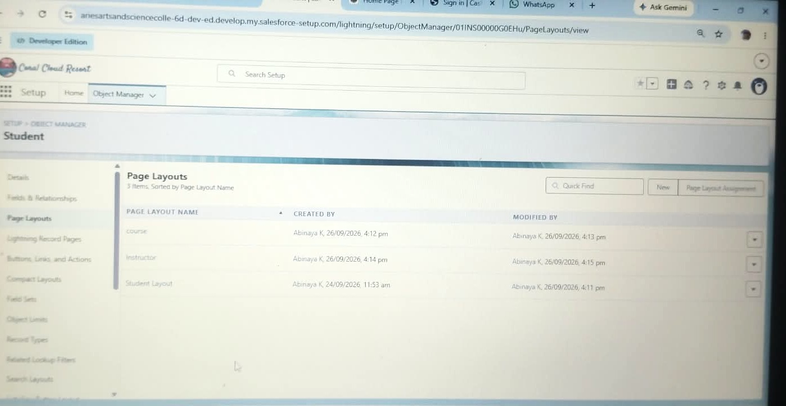

The purpose of page layout customization is to make records easier to view and manage.
Required fields are arranged in a logical order so that users can enter and view information efficiently.

6.8 Milestone 8 – Validation Rules
Validation Rules are created to prevent incorrect or incomplete information from being saved.
Validation rules help ensure data accuracy and maintain the required conditions during record creation and updating.
Examples include:
- Mandatory field validation
- Eligibility validation
- Enrollment constraints
- Duplicate enrollment prevention
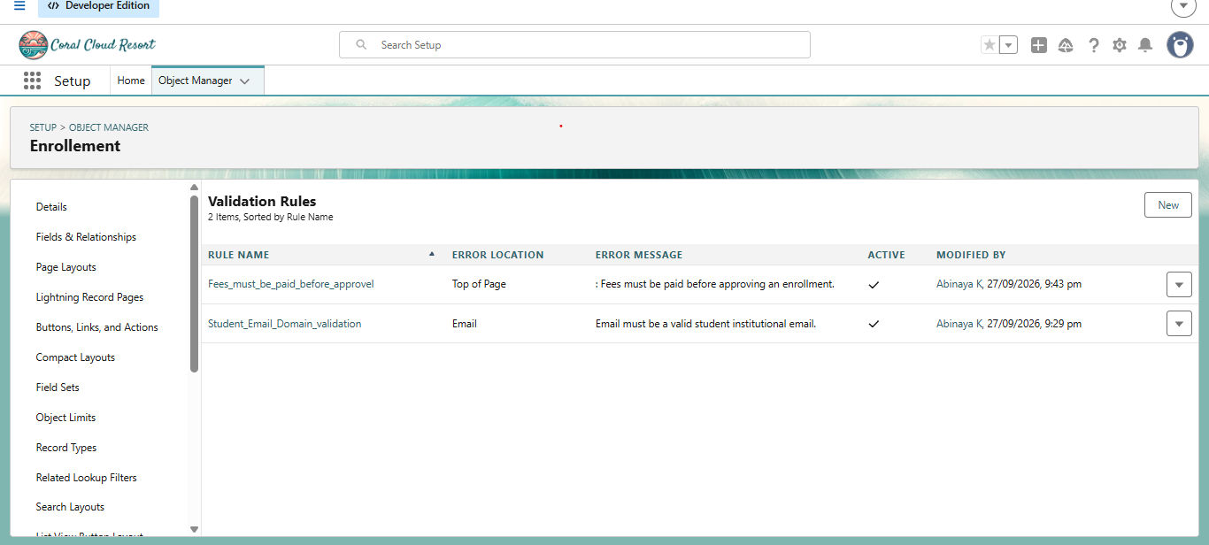
6.9 Milestone 9 – Flows / Automation
Salesforce Flows are used to automate important processes.
The project uses automation for activities such as:
- Enrollment processing
- Approval-related actions
- Seat availability checks
- Instructor assignment
- Automatic record updates
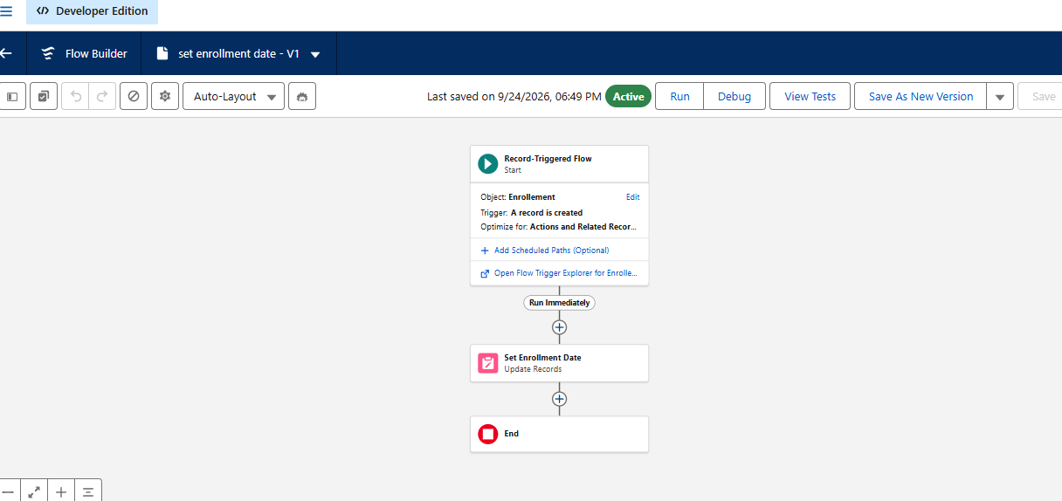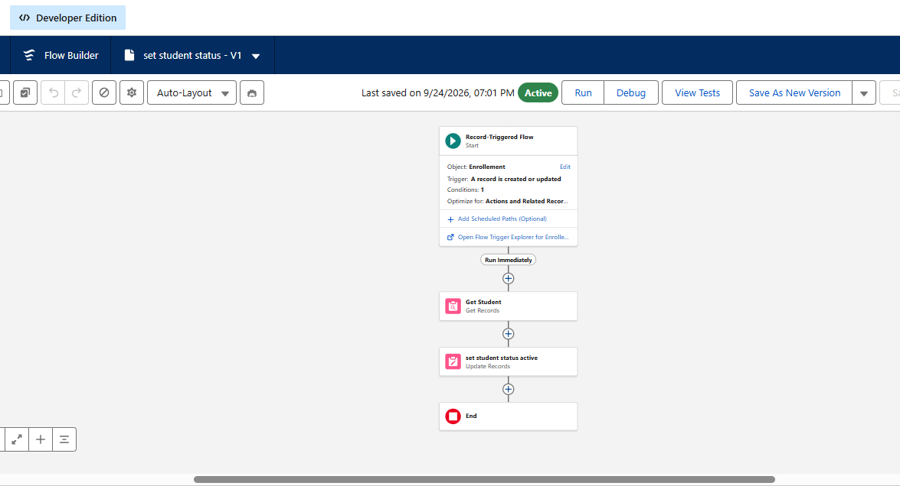
Flows reduce the need for users to perform repetitive operations manually.

6.10 Milestone 10 – Approval Process
An Approval Process is configured for enrollment-related approval.
The process routes the required enrollment records for approval.
The enrollment can move through the configured approval stages based on the project conditions.
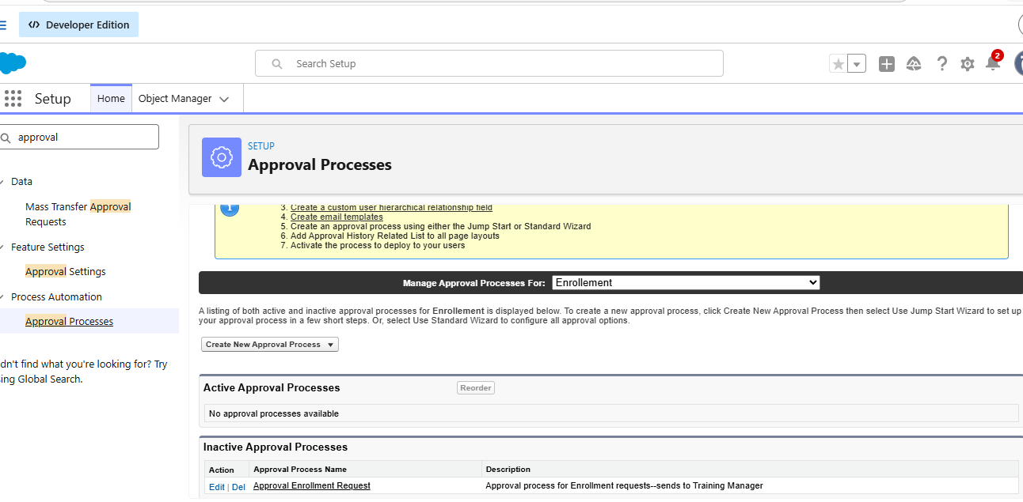
This helps create a structured approval workflow.
6.11 Milestone 11 – Reports
Reports are created to organize and analyze the information stored in Salesforce.
Examples include:
- Student reports
- Enrollment reports
- Enrollment by Course
- Revenue / Fees Paid report
- Pending Enrollment Approvals report
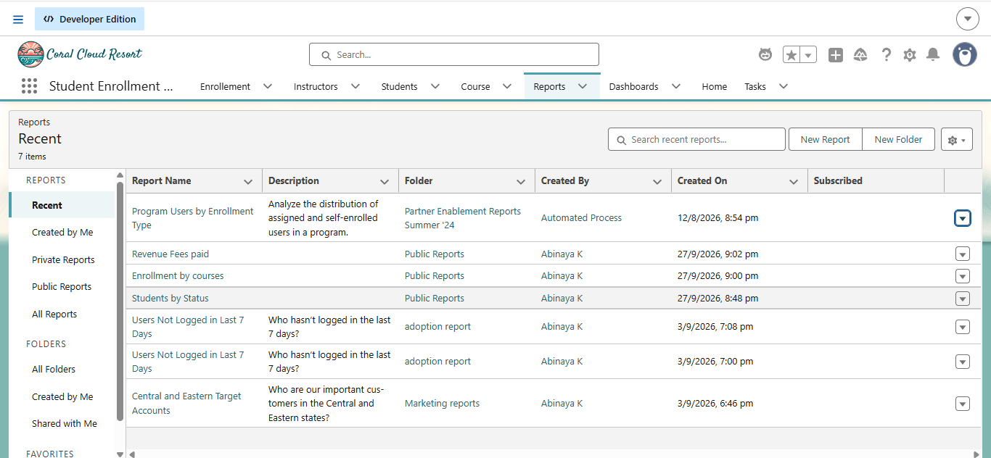
Reports help administrators and enrollment officers monitor important information.
6.12 Milestone 12 – Dashboard
A Student Management Dashboard is created.
The dashboard contains different report components to provide a visual summary of the project data.
The dashboard can include:
- Donut Chart – Students by Status
- Bar Chart – Enrollments by Course
- Gauge – Revenue / Fees Paid
- Table – Pending Enrollment Approvals
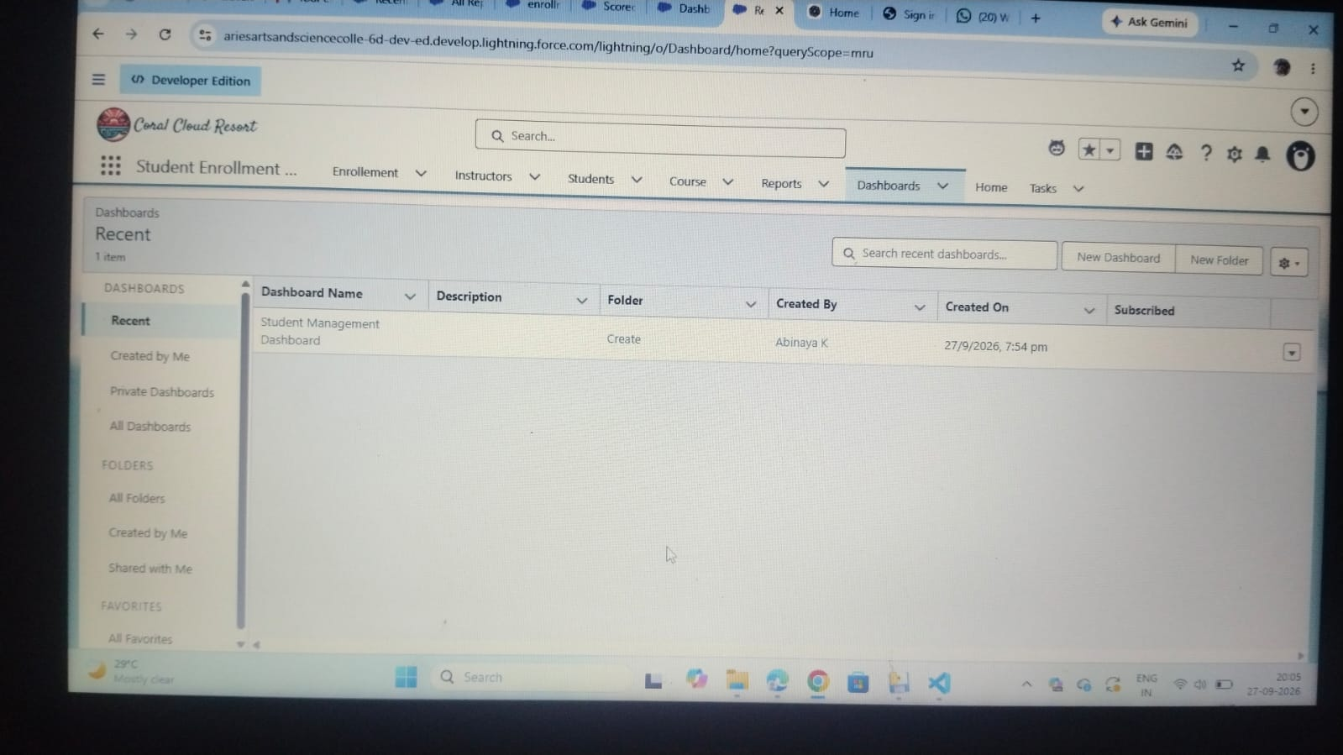
The dashboard allows important information to be viewed in a single location.
6.13 Milestone 13 – Security Setup
Security is configured using Salesforce security features.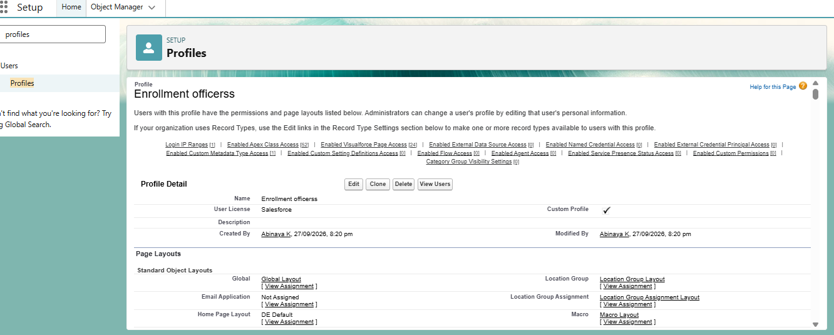
Profiles
The project defines roles such as:
- Admin
- Enrollment Officer
- Instructor
The Admin has full access to the required project components.
The Enrollment Officer can create and update enrollment information.
The Instructor has read-only access to the assigned enrollment information.
Permission Sets
Permission Sets can be created to provide additional access where required.
Examples include:
- Custom Object Access
- Dashboard Editor
Sharing and Organization-Wide Defaults
Sharing settings are configured according to the project requirements.
The project specifies:
- Students – Public Read/Write
- Courses – Public Read/Write
- Enrollments – Private
Additional access can be provided through the required Salesforce configuration.

7. FUNCTIONAL & PERFORMANCE TESTING
Testing is performed to verify that the implemented Salesforce components work correctly.
The following areas are tested:
Student Management
Student records are created and checked to ensure that the required information is stored correctly.
Course Management
Course records are created and verified.
Instructor Management
Instructor records are created and related information is checked.
Enrollment Management
Enrollment records are created and tested with the required student, course, and instructor relationships.
Validation Testing
Validation rules are tested by entering incorrect or incomplete information.
The system should prevent invalid records from being saved when the configured conditions are not satisfied.
Flow Testing
Salesforce Flows are tested to verify that the configured automation executes correctly.
Approval Testing
The approval process is tested to verify that enrollment records follow the configured approval workflow.

Reports Testing
Reports are checked to ensure that the correct records and information are displayed.
Dashboard Testing
Dashboard components are verified to ensure that the displayed information matches the underlying reports.
Security Testing
Different user access levels are tested to ensure that users can access only the information and features provided to their roles.
The PDF specifies capturing screenshots during testing to demonstrate the functioning of these features.

8. ADVANTAGES & DISADVANTAGES
8.1 Advantages
Centralized Data
All major student, course, instructor, and enrollment information can be maintained in one Salesforce environment.
Automated Workflows
Flows and approval processes reduce repetitive manual activities.
Real-Time Reporting
Reports and dashboards provide organized and visual information for monitoring academic activities.
Improved Data Accuracy
Validation rules help reduce incorrect and incomplete data.
Better Monitoring
Dashboards allow important information to be viewed easily.
8.2 Disadvantages
Salesforce Dependency
The application depends on the Salesforce platform.
Initial Configuration Effort
Setting up objects, fields, relationships, automation, security, reports, and dashboards requires initial configuration effort.

9. CONCLUSION
The Student Enrollment & Course Management System (SECMS) provides a centralized Salesforce-based solution for managing student academic enrollment activities.
The system manages student records, courses, enrollments, instructor assignments, approvals, revenue-related information, reports, and dashboards.
By using Salesforce features such as Validation Rules, Flows, Approval Processes, Reports, Dashboards, Profiles, Permission Sets, and Sharing Settings, the system can reduce manual processes and improve data management.
The project demonstrates how Salesforce can be used to transform manual academic enrollment activities into a structured and automated digital solution.
Overall, SECMS provides a scalable and organized approach for managing the academic enrollment lifecycle within an educational institution.

10. FUTURE SCOPE
The project can be extended with additional features in the future.
10.1 Payment Gateway Integration
A payment gateway can be integrated to allow online fee payments and transaction management.

10.2 Student Self-Service Portal
A student portal can be developed so that students can access their own enrollment and course information.
10.3 Analytics-Driven Insights
Advanced analytics can be added to provide deeper insights into enrollment trends, revenue, student status, and course demand.
10.4 Mobile Access Support
The system can be extended to provide better mobile access and support for users.

11. APPENDIX
11.1 Source Code
The project implementation consists mainly of Salesforce configuration and development components, including:
- Salesforce Custom Objects
- Custom Fields
- Relationships
- Page Layouts
- Validation Rules
- Salesforce Flows
- Approval Process
- Reports
- Dashboards
- Security Configuration
11.2 Dataset
The Salesforce Objects contain the project data related to:
- Students
- Courses
- Instructors
- Enrollments
11.3 Project Demonstration
The completed project can be demonstrated through the configured Salesforce Developer Org.
Screenshots of the Salesforce implementation, testing process, reports, dashboards, flows, and security configuration can be included in this section.

THANK YOU

